**Brooklyn torah gazette**

**For parshas bereishis 5781**

Volume 5, Issue 5 (Whole Number 205) 29 Tishrei 5781/ October 17, 2020

**Printed L’illuy nishmas Nechama bas R’ Noach, a”h**

**Op Ed**

**Anti-Semitic Democrats Blame Orthodox Jews**

**For the Coronavirus**

**By Daniel Greenfield**

***The two top Democrats who mishandled the pandemic, while spewing lies, excuses and smears, won’t be held accountable.***



**Governor Cuomo and Mayor de Blasio**

(JNS) “I have to say to the Orthodox community tomorrow, ‘If you’re not willing to live with these rules, then I’m going to close the synagogues,’” Governor Andrew Cuomo told religious Jews.

His basis for the decree was a photo of mourners who weren’t practicing social distancing at a funeral. But the photo of a crowd of Orthodox Jews on Cuomo’s slide was from 2006.

**A Very Different Message**

It was a very different message than Cuomo’s condemnation of bigotry when he had insisted, “There is zero evidence that people of Asian descent bear any additional responsibility for the transmission of the coronavirus.” The new message is, don’t blame the Asians, blame the Jews.

They did go to a funeral in 2006.

Cuomo was picking up where Mayor Bill de Blasio had left off in his infamous tweet targeting Orthodox Jews. “My message to the Jewish community, and all communities, is this simple: the time for warnings has passed,” the New York City leftist boss had raged.

Medieval bigots blamed the Black Plague on Jews poisoning wells. Modern Democrats blame the coronavirus on the Jews. Despite the plague of media narratives accompanied by photos of Chassidic Jews praying or mourning, there’s as little evidence for the latter as for the former.

Cuomo’s threat to synagogues was prompted by a supposed resurgence of the virus. De Blasio had already announced that the spike in the targeted areas would lead to school and business closures. Except that a number of those areas have African-American, Latino or Asian majorities. But instead Democrats and the media have focused in on the “Jewish” areas.

**Far From a Homogenous Mono-cultural Community**

And even those “Orthodox Jews” areas are far from a homogenous mono-cultural community.

Chassidic Jews, a subset of Orthodox Jews, may stand out, but so do the Amish. So-called “Chassidic neighborhoods” in Brooklyn are actually made up of the usual New York mix of African-Americans, Latinos and assorted immigrant groups, including Muslim immigrants.

Coronavirus deaths among Asians in New York have been twice as high among whites and approaching five times as high among Latinos and African-Americans. New York City’s worst death rates were not in Borough Park or Williamsburg, but in a Bronx neighborhood, in East New York, in Flushing, Queens, in Far Rockaway and in Brighton Beach.

None of those are Chassidic neighborhoods. Only one has a significant Orthodox population.

Nor are the highest positive rates in Orthodox or Chassidic areas. You have to get through five Queens neighborhoods before making it to Borough Park. And Borough Park, and most Brooklyn neighborhoods, except East New York, are far below Queens and Bronx neighborhoods when it comes to cases per population. Borough Park is only the 49th highest zip code in actual mortality rates, Williamsburg is in 79th place.

**The Claim that the Outbreak is an**

**Orthodox Jewish Problem is Ubiquitous**

And yet the insistence that the outbreak is an Orthodox Jewish problem is ubiquitous. It pops up in the media and in rhetoric by top Democrats that stigmatizes religious Jews for the virus.

The Democrats who rose to denounce scapegoating of Asians have joined in the racism.

The media pumps out stories blaming the outbreak on Orthodox Jews with a cheerful disregard for facts or basic urban geography. The *Associated Press* rolled out an entire story blaming the outbreak of coronavirus infections on Orthodox Jews, but the only actual neighborhood that it offers statistics for is the “Gravesend section of Brooklyn,” a mostly immigrant area that is not home to a Chassidic community and whose Orthodox Jews are Syrian refugees, but is mostly associated with Italian-Americans, with large populations of Chinese and Russian immigrants.

The media won’t stop claiming that Orthodox Jews spread the virus because they make a convenient boogeyman for its hipster readers who despise traditional Judeo-Christian religions.

**The New York Times Has Run Many**

**Articles Blaming Orthodox Jews**

The*New York Times*, which has run the most articles blaming Orthodox Jews for the outbreak, has linked them to cultural lefty hobgoblins like opponents of vaccines and Trump supporters.

“N.Y.C. Threatens Orthodox Jewish Areas on Virus, but Trump’s Impact Is Seen,” one *New York Times* headline read.

The power of othering is that all your hatreds and fears can be projected onto those who are different. And despite all the politically correct lectures on race and hate, the *Times*needs its own others to hate. The most obvious “tell” is that when the *Times* writes about any other group, it quotes members of the community, but when it writes about Chassidic Jews, it turns to opponents and critics of the community who are happy to nod along to the negative coverage.

That’s why a rise in positive test results in a Chinese area isn’t a story, a rise in a black area is a story about racism and inequity, but a rise in an Orthodox Jewish area is a story about ignorant religious fanatics who support Trump, insist on praying and don’t trust the medical experts.

The Orthodox Jewish community has suffered from the virus, as have many other groups. It’s no more at fault for it than they are. It isn’t unique because more Orthodox Jews have come down with the virus, but because they make a convenient scapegoat for the failures of Democrat officials like Cuomo and De Blasio, for the blatant flouting of their rules by rioters and hipsters.

Chassidic Jews in particular are stereotypically “other” with strange garb, incomprehensible beliefs, accents, large families and long beards, but they’re white enough that hating them is socially acceptable for progressives who can act out their xenophobia without feeling guilty.

**The Media was Eager to Provide a**

**Platform for Those Bashing Orthodox Jews**

Even before the pandemic, the media was eager to provide a platform for every special interest out to bash Orthodox Jews, from the [YAFFED](https://www.frontpagemag.com/fpm/2019/01/send-your-son-leftist-school-or-government-will-daniel-greenfield/) campaign by leftists against religious Jewish schools to opponents of circumcision to animal rights cranks campaigning against Kosher meat.

The new coronavirus anti-Semitism relies on the same stereotypes and slurs: Orthodox Jews are ignorant, superstitious, flout authority and need to be saved from their backward ways. These are the progressive prejudices that permeate the media’s coverage of Orthodox Jews. And it’s part of the reason why Orthodox Jews are a Republican constituency in presidential elections.

Bigotry isn’t just about the pleasures of hate. It’s how those in power redirect blame for their crimes and failures, and a means for those who hate to gain a false sense of power and control.

**Creating a False Sense of Security for Everyone Else**

Blaming the upsurge on an outside group creates a false sense of security for everyone else.

And when it’s no longer possible to pretend that the upsurge is limited to Orthodox Jews, then they can still be blamed for having caused it with their weddings, funerals and their prayers.

Best of all, none of the newfound bigots will blame Governor Cuomo or Mayor Bill de Blasio.

The two top Democrats who mishandled the pandemic in the worst ways possible, while spewing lies, excuses and smears at their serial press conferences, won’t be held accountable.

And that’s why every time things get worse, Cuomo and De Blasio will blame the Jews.

*Daniel Greenfield, a Shillman Journalism Fellow at the Freedom Center, is an investigative journalist and writer focusing on the radical left and Islamic terrorism.*

*Reprinted from the October 10, 2020 email of Arutz Sheva. This article was first published by FrontPage Magazine.*

**Rabbi Berel Wein on**

**Parshat Bereshith 5781**

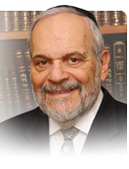

This week's opening parsha of the Torah can be viewed as having bookends. There are two main characters in the story of humanity that are introduced to us. At the beginning of the parsha, the Torah tells us of the creation of Adam, the original human being, and the progenitor of all of us. Thus, the Torah records the tragedy of his life and he becomes, so to speak, the story of all human beings who are prone and susceptible to sin and temptation, who live on in regret and recrimination.

Even though Adam will live an exceptionally long life, almost a millennium, we are not told much about the rest of his life. According to midrashic tradition, Adam spent most of his life in loneliness, isolation, sadness, and depression over his transgression, and this affected not only him, but all humanity as well.

Jewish tradition teaches us that there were 10 generations, over 1500 years, between Adam and the generation of Noah and the great flood. These generations sank further and further into the abyss of idolatry, paganism, immorality, robbery, tyranny, and brutality. Adam, who certainly was aware of what was happening, apparently was of no influence on these generations.

**Seemingly Withdrew into His Isolation and Sadness**

Instead of being an exemplary influence and a leader, he seemingly withdrew into his own isolation and sadness. We can certainly sympathize and even empathize with his behavior, but his non-actions do not, in any way, aid the cause of humanity, nor its spiritual and emotional development and growth.

At the conclusion of the parsha, we are introduced to Noah, who will be the central character in the drama of the Flood that we will read about in next week's Torah reading. We see a somewhat similar story with Noah as we saw with Adam. After surviving the flood and having the opportunity to build the world in a more positive fashion, he also fails the test, and loses influence on his children and succeeding generations.

He also lives an exceptionally long life, almost a millennium, but extraordinarily little is revealed to us about the rest of his days, or what other accomplishments, if any, he achieved. Noah, like Adam, remains an enigmatic figure, a reservoir of failed potential and human decline.

**Of Little Influence in Being Able to Stem a Tide of Evil and Brutality**

We are taught there were, once again, 10 generations from Noah to Abraham and that these 10 generations – and Noah was alive for a great deal of them – simply sank back into the idolatry, paganism and immorality of the time of Adam. And, once again, Noah apparently was of little of any influence in being able to stem this tide of evil and brutality.

It is only once we reached the story of Abraham and Sarah that we find people who not only were pious in their own right, as Noah certainly was, but who also had an enormous influence upon their times and all later times, as well. And Abraham and Sarah are the example that is set before us.

We all are people of influence, on our families, communities, and societies. We must see ourselves in that light, and behave accordingly, and reveal ourselves as examples and influence. That has been our mission from time immemorial and remains so until today.

*Reprinted from this week’s website of rabbiwein.com*

**Why Did G-d Create**

**The Evil Inclination?**

**From the Talks of the Lubavitcher Rebbe**

**Rabbi Menachem Mendel Schneerson, Zt”l**

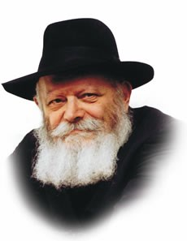

According to the Talmud, the sin of the Tree of Knowledge and Adam and Eve's expulsion from the Garden of Eden occurred on the very same day they were created -- Friday, the sixth day of Creation.

In this context, G-d's declaration in this week's Torah portion, Bereishis, is therefore surprising: "And G-d saw everything that He had made, and behold, it was very good." How can it be that G-d considers sin and punishment not only good, but "very good"?

**The Sages Comments Only Add to Our Perplexity**

The comments of our Sages on these words only add to our perplexity. " 'Good'-- this refers to the Good Inclination. `Very' -- this refers to the Evil Inclination."

"`Good' is the Angel of Life; `very' is the Angel of Death." What were our Rabbis trying to tell us?

In order to understand, we need to look at why G-d, the epitome of good, created evil in the first place.

As the Evil Inclination, the Angel of Death, and the Serpent were all created by G-d, we must therefore conclude that the inner essence of these creations is also good, even though their external appearance seems otherwise.

**What Exactly is the Inner Good?**

And what exactly is this inner good? In essence, it is the power of teshuva -- the ability to return to G-d in repentance. For without evil, the phenomenon of teshuva could not exist. Without an Evil Inclination inciting us to disobey, we could never achieve the higher spiritual heights that are attained through teshuva, a process by which even our "deliberate sins are transformed into merits."

This, then, is the meaning of G-d's pronouncement on that first Friday: everything that He created is part of the Divine plan for the world to attain fulfillment. Endowing man with an Evil Inclination allows him to achieve an even higher level of perfection than that with which he was created.

**The Advantage of the Light that Comes**

**From the Very Depths of the Darkness**

Of course, sin itself is wicked, for it is contradictory to G-d's will. But after a person has sinned and done teshuva, he is on a higher level than a righteous person who has never transgressed! This concept is known as the "advantage of the light" that comes from the very depths of the darkness.

This principle contains an eternal message for us in our daily lives: If a person should claim that he is not responsible for his misdeeds, G-d having created him with an inborn inclination and propensity for sin, he should remember that the sole reason for the creation of the Evil Inclination is that it lead us to a higher rung in our service of G-d!

Thus it is through the temporary descent into sin and our subsequent teshuva that we reach the level of "very good" -- the objective of all of Creation, and its ultimate perfection which will take place in the Messianic Era, speedily in our day.

*Reprinted from the Parshat Bereisiti 5756 edition of the L’Chaim Weekly, a publication of the Lubavitch Youth Organization. Adapted from Likutei Sichot of the Lubavitcher Rebbe, 5749 Vol. 1*

**Parshas Bereishis**

**The Beginning of Time**

**By Rabbi Bentzion Shafier**

**Founder of TheSmuz.com**

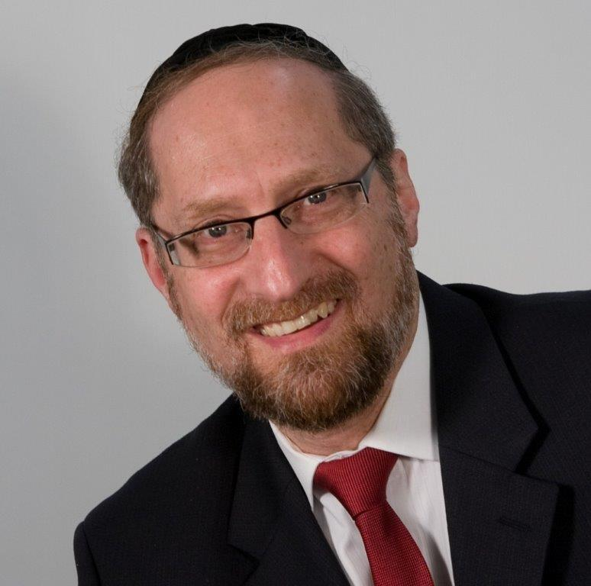

“*In the beginning, HASHEM created the heavens and the earth*.” – Bereishis 1:1

The Siforno explains that “in the beginning” means, “at the beginning of time – the very first moment. Before this, there was no time.”

The Siforno seems to be saying that when HASHEM created the world, it wasn’t only the physical world that He created, but He created time itself. And so, when the Torah says, “in the beginning,” it means at the very first moment in time because before this, there was no time.

This Siforno is difficult to understand as the Medrash that tells us that HASHEM wrote the Torah many generations before He created the world. And even more significantly, it is self-evident that HASHEM existed before He created the world. So how can the Siforno say that at the very first moment of time, HASHEM created the world when clearly some things existed before this time?

In order to answer this question, a moshol will be helpful.

**How Heavy Were Elephants Before Creation?**

Imagine that before Creation, two angels were having a conversation:

“I heard that HASHEM is going to create an entire physical world,” one angel says to his friend.

“Really? What will exist in this physical world?”

“Oh, there will be birds and flowers, trees and oceans, and animals, some small and some large. There will even be a huge behemoth called an elephant.”

“Fascinating. Tell me; how heavy is this thing you call an `elephant’?”

This question (as well as the conversation) never took place because before HASHEM created the physical world, there was no concept of weight. Weight is a measure that is relevant to a physical world. Before HASHEM created physicality, there was nothing to measure, so the system of measuring weight by ounces and pounds didn’t exist.

So too, before the act of Creation, if you were to ask how tall the giraffes would be, there wouldn’t be an answer because inches and feet are measures that are relative to a physical existence. Before there was physicality, there was nothing to measure, so there was no system to measure height. Even something as ethereal as light can only be measured in a physical world. Before creation there was no light, so a system of measuring luminosity didn’t exist.

**The First Moment of Time**

This seems to be the answer to the Siforno. In the physical world time is relevant. Everything physical has a beginning and an end. You can measure its age and life expectancy, and then compute its half-life. But that is because the physical world is temporary, and everything in it has a set amount of time to exist and then is no longer. Since that existence is limited in span, it is measurable. The spiritual world doesn’t function that way. Things in the spiritual world are. Once they begin, they remain. However, change isn’t part of that reality, and so any measurement system dependent upon change isn’t relevant.

This seems to be what the Siforno means when he says, “In the beginning, at the first moment of time.” Before Creation, there was no time because time is a measure of a physical existence. In a spiritual world, there is no such concept as time because nothing is affected by time. Things are. It was only when HASHEM created the heavens and the earth that anything physical came into being, so it was only then that there could be a system to measure time. At that moment, time itself came into being.

**I Am a Spiritual Being**

This concept is helpful to us in relating to one of most of the most illuminating facts in our existence: that I will live forever. My body will die, and I – the part that thinks, feels, and remembers – will live on long after it. Reb Yisroel Salanter compares death to taking off a coat. When I take off my coat, I emerge. Not some splintered version of me, but me minus an outer garment. So too, after my body dies, I live on.

We tend to get confused and think of ourselves as physical beings with a spiritual component, as if I am 85% physical with a soul hidden deep down inside there somewhere. That is patently false. We are spiritual beings temporarily in a physical experience. I, the one who is housed inside this body, am completely and utterly spiritual. For a short while, I am connected to this outer shell, but in due time, my body will die and it will be buried in the ground. I, the one who tells my arms and legs to move, will emerge and live on forever. Who I am and what I shape myself into therefore has great relevance because that is what I will be for eternity.

**I Can Change**

With this understanding comes a vital revelation: as long as I am alive, I can change. Spiritual entities are. As they were created, they remain – static, frozen forever. As great as a moloch may be, whatever level he began on, he remains there. Change practically doesn’t exist in the spiritual world. One of the most critical understandings of life is that as long as I am in this world, I can change, grow, and make myself into a vastly different person than I was a day ago or a year ago. But once I leave this earth, everything stops. I am what I shaped myself into, and that is where I remain. I will live forever, but I get only one shot at eternity. What I make myself into now is what I will be forever.

*Reprinted from this week’s website on TheShmuz.com This is an excerpt from the [Shmuz on the Parsha book](https://theshmuz.com/product/shmuz-on-the-parsha-book/).*

**When You Have Just 60 Seconds to Say Goodbye**

**By Rabbi** [**Chaim Kosofsky**](https://www.chabad.org/search/keyword_cdo/kid/17902/jewish/Kosofsky-Chaim.htm)

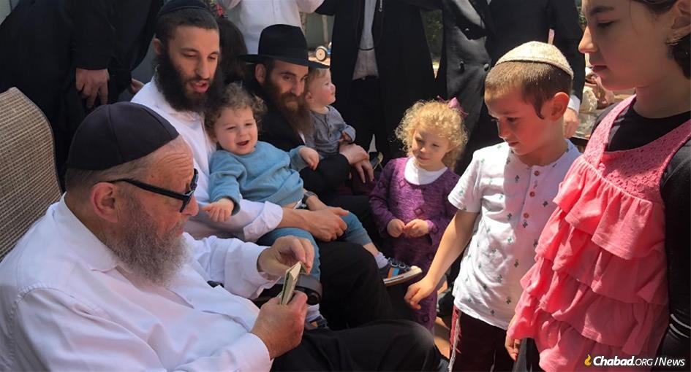

**Yitzchok Kosofsky enjoyed the pleasure of spending time with his many children, grandchildren and great-grandchildren.**

COVID has turned our world upside down.

One of the biggest changes that has taken place is in hospitals and senior facilities. People can no longer visit, and patients are in the hospital alone, without family.

My father, [Yitzchok Kosofsky](https://www.chabad.org/news/article_cdo/aid/4722280/jewish/Yitzchok-Kosofsky-89-the-CPA-Behind-Kosher-Milk-for-Chicago.htm" \o "Yitzchok Kosofsky, 89, the CPA Behind Kosher Milk for Chicago), entered the hospital before COVID. He never made it back home.

Over four months in the hospital, his body grew weaker and began to shut down. He didn’t want to eat. We put on his *[tefillin](https://www.chabad.org/library/article_cdo/aid/1918251/jewish/What-Are-Tefillin.htm" \o "What Are Tefillin?)* for him, he mumbled the [Shema](https://www.chabad.org/library/article_cdo/aid/705353/jewish/The-Shema.htm) and signaled that he was ready to take them off. He hardly spoke, and when he did, it was just a few words.

Children and grandchildren traveled to California to visit and help, sitting at his bedside, coaxing him to eat, even staying overnight in the hospital room. For a while, he was in rehab in a nursing home, across the hall from our mother.

When the lockdown began, all hospital visitations stopped. Communication with the doctors and therapists took place by phone. Hospital staff put *tefillin* on him, guided by a family member over Zoom.

**A Few Weeks After the Lockdown, His**

**Condition Took a Turn for the Worse**

A few weeks after the lockdown began, his condition took a turn for the worse. Doctors performed several emergency procedures, which were successful, but new problems arose. It reached the point where his body ceased to respond to treatments, and it was clear he had just a few days left to live.

It was time to say our final farewells.

He hadn’t spoken on the phone in several months, and besides, he was no longer conscious. Any conversation would be one-way.

Our sister notified us Sunday afternoon that she would set up a video call on Whatsapp with the hospital chaplain, who would be in the room with our father. As we are nine children, we would each get just 60 seconds to say goodbye.

Sixty seconds? A single minute? What do you say?

My siblings and I are no strangers to public speaking. We are rabbis and teachers in our communities from the Northeast to California, in Australia and Argentina. We all give lectures and classes. I’ve conducted difficult funerals. Yet, this was something different.

**When the Initial Panic Subsided, I Collected My Thoughts**

I ran to the quiet of my bedroom, away from the household commotion, where I could think. When the initial panic subsided, I collected my thoughts:

Before someone passes, it is important to ask forgiveness for any wrong you may have done. This is especially true for a parent, whom we are required to treat with great esteem.

It is likewise important to express forgiveness for any slights the person who is passing may have committed. We want the deceased to proceed to the next world with no hurtful actions and words on his record.

My father had the great privilege to meet the sixth Lubavitcher Rebbe, [Rabbi Yosef Y. Schneersohn](https://www.chabad.org/library/article_cdo/aid/110174/jewish/Rabbi-Yosef-Yitzchak-Schneersohn.htm), with his Hebrew school class, when the Rebbe visited Chicago in 1942. In the years that followed, he made the decision to become a chassid of the Rebbe, and he raised us in that tradition. I should thank my father for bringing me up with a passion for the Rebbe’s teachings and directives, something to which I’ve devoted my life.

Years ago, my father introduced me to a fascinating book called Shnei Luchot Haberit (Shelah). This led to me teaching a weekly class for adults on Arizal. I would often share the fascinating connections and *gematria* that I had read, and he would say, “How do you like that!” (As an accountant and as someone with a talent for numbers, he appreciated teachings with *gematria*.) I would have to thank him for opening the world of Shelah to me.

**The Biggest Tribute I Could Give My Father**

The biggest tribute I could give my father is to give him *nachas* (pride). So it would be appropriate to state that I hope I have made him proud, and will continue to do so.

With my mind and heart racing, checking if there was anything I had missed, I jotted down these five points and waited anxiously for my turn to speak. I tried to stay calm and keep my head clear.

My phone rang for a video call, and I could see my father in his hospital bed, hooked up to tubes and wires. I spoke as I had planned, knowing this was the last time I would speak to and see my father until Moshiach comes. I made sure to speak in a tone that was calm and comforting.

When I was done, I thanked the chaplain for providing us this opportunity to say goodbye.

I remember taking a deep breath when I hung up.

Our father hung on for two more days, before passing away from old age shortly after his 89th birthday.

**We Were United in the Things He Held Dear**

While his family was not with him physically at the time of his death, we were united in the things he held dear: a love for Torah and a dedication to the Rebbe’s teachings.

Looking back, I realize the topics I mentioned in those 60 seconds - devotion to the Rebbe, studying Shelah, and bringing my father *nachas*- are what bring me comfort in the months since his passing.

Rabbi Chaim Kosofsky is a Lubavitcher Shliach at Lubavitcher Yeshiva Academy in Longmeadow, MA, where he teaches Judaic studies. He also teaches adult education and coordinates outreach programs for Beis Medresh Lubavitch. Rabbi Kosofsky is the author of Much, Much Better (Hachai, 2006).

*Reprinted from this week’s email of Chabad.Org Magazine.*

**Teaneck Man Writes Memoir About His Father’s**

**Death from Cancer**

**By Abigail Klein Leichman**

[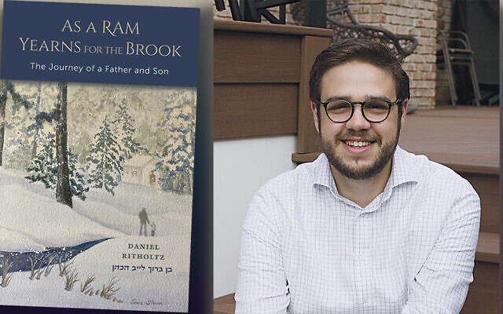](https://static.timesofisrael.com/jewishstanddev/uploads/2020/10/12-1-Dani-Ritholtz.jpg)

**Daniel Ritholtz described how he coped with his father’s death, and how the community helped him.**

The recent Zoom event where Daniel Ritholtz introduced his newly published memoir of the events surrounding his father’s death six years ago was not simply a book launch.

It was also an expression of gratitude to his audience, members of Teaneck’s Congregation Rinat Yisrael, for their loving support of the Ritholtz family throughout that trying time.

“The rabbis, leadership, and community of Rinat really helped us so much while my dad was sick and even afterwards, and I know how much this community meant to my dad,” Mr. Ritholtz said. “We were only in Teaneck four years before he passed away, but he had deep ties to people here.”

**A 24-Year-Old Rabbinical Student**

Today, Mr. Ritholtz is a 24-year-old rabbinical student at Yeshiva University’s Rabbi Isaac Elchanon Theological Seminary. He also hopes to go to law school.

In 2010, the family moved to Teaneck from Manhattan, where Bruce and Michelle Ritholtz had been active members of Lincoln Square Synagogue. They timed the move to coincide with Dani’s freshman year at Torah Academy of Bergen County. The high school’s dean, Rabbi Yosef Adler, also is the spiritual leader of Rinat Yisrael, and he grew close to the family.

Three years later, Bruce Ritholtz was diagnosed with pancreatic cancer. He died the following year. He was 57.

“As a Ram Yearns for the Brook: The Journey of a Father and Son” went on sale on Amazon on September 22. The date corresponded to 4 Tishrei on the Jewish calendar, which was Bruce Ritholtz’s sixth yahrzeit.

**A Two-Year Labor of Love for His Father**

Dani Ritholtz describes the book as “a two-year labor of love for my father. The story of my father and the relationship I had with him is told through the medium of letters, real and imagined, through the highs and lows of a normal Modern Orthodox upbringing and the extremes of a family fighting cancer and dealing with loss.”

The process of writing was cathartic and therapeutic, he said. It triggered “very honest conversations and amazing discussions” with his mother and with his sisters, Annie and Talia.

Several reasons led him to the decision to share his writing with the public rather than keep it within the family, he explained. “Giving a genuine account of my own experiences lets you get into the mind of someone going through something difficult and maybe you can relate more to another person suffering a tragedy.”

He also wanted to be upfront about his bouts of depression during the grieving process.

When he got the phone call that his father had died, Mr. Ritholtz was 6,000 miles away in the dorm at Yeshivat HaKotel in Jerusalem, just beginning his first gap year. His maternal grandmother, whom he called Bobie, died — also of pancreatic cancer — as Mr. Ritholtz was starting his second year at HaKotel.

The book’s entry from August 31, 2015, relates: “I feel a weight . . . I can’t get out of bed. There’s a brick wall separating me from everything, including Him. Bobie passed away a few weeks ago, the day I finished the eleven months of saying Kaddish for my dad . . . hours after, actually. … Afterwards I tried to sit down to learn, but the realization of what had just transpired punched me in my gut, and I felt absolutely sick. Not physically ill like I’ve felt so many times, but emotionally.”

**The Brick Wall Bearing Down on the Son**

That brick wall would continue to bear down on him from time to time. His entry from December 8, 2018, reads: “I thought after my last excursion with depression, I had learned and gained the tools to fight it, to deal with the negative thoughts and the brick walls that fell on top of me. But they came again.”

With the help of professional therapy, as well as his family, friends, and rabbis with whom he was close, Mr. Ritholtz prevailed over the heavy bricks.

“Mental health issues are not talked about a lot, especially in the Jewish community and specifically in the Orthodox community,” he said. “I hope that what I wrote will be helpful for people who want to be there for friends and family members going through difficulties, whether physical or mental illness.”

He has pledged to donate 20 percent of the proceeds from the sales of “As a Ram Yearns for the Brook” to the Lustgarten Foundation and Refuat Hanefesh.

“The Lustgarten Foundation’s mission is to cure pancreatic cancer by funding scientific and clinical research related to the diagnosis, treatment, and prevention of pancreatic cancer; providing research information and clinical support services to patients, caregivers and individuals at high risk; and increasing public awareness and hope for those dealing with this disease. Refuat Hanefesh, a Jewish organization, aims to create a Jewish community that is more aware, respectful, and empathetic to people living with mental illness,” he said.

**Title Taken from a Verse in Psalm 42**

The title of the book is taken from a verse in Psalm 42, in which King David describes his instinctual yearning for G-d.

“There are many explanations for what this can mean, but at least for me, it means that our relationship with G-d is beyond explanation,” Mr. Ritholtz writes. “We yearn for Him from the depths of our hearts and souls but, just as the ram cannot conceptualize his thirst, so too, we cannot get to the core of our passion for G-d; we just feel it. This experiential way of connecting to G-d is something I saw my father regularly practice.”

He noted that his father had been thinking of writing a book about his experiences with cancer and how he managed to stay positive with the help of family, friends, community, and his faith in G-d.

While ultimately Bruce Ritholtz didn’t have the opportunity to write such a book, his son did.

“This was a story that was swirling in me and I wanted to tell it because my dad couldn’t. I hope it contains elements and themes he would have included in his own book,” Dani Ritholtz said.

**So Much Good that Came Out of this Tragedy**

“For me, the book doesn’t change anything. I wish I wouldn’t have written this, that my dad could have written a book himself. But there was so much good that came out of this tragedy, so much chesed and bikkur cholim” — acts of kindness and visiting the sick — “and so much Torah.”

For example, hundreds of people pledged to study sections of the Talmud hoping to effect healing for Bruce Ritholtz. Leaders and members of Congregation Rinat Yisrael held Shabbat services in the Ritholtz home for eight months, so that Bruce could continue to pray with a minyan as he underwent chemotherapy.

“That’s what I am trying to focus on in my book,” Mr. Ritholtz said. “It doesn’t change the bigger picture; it just acknowledges the good that the bad came with.”

He expressed gratitude to family friend Morton Landowne, the executive director of Nextbook, the not-for-profit organization behind the online Jewish magazine Tablet and the Jewish Encounters book series.

“I showed him the manuscript and he said I should get it published and got me in contact with a lot of people,” Mr. Ritholtz said. “I knew nothing about the publishing world.”

**Chose to Self-Publish in Order to Retain Control**

In the end, he chose to self-publish in order to retain control over the project, even though that entailed finding a typesetter, editor and cover designer — all in Israel — and learning the ropes of selling a book on Amazon.

“Thank G-d, I had a lot of guidance,” he said. “It was a lot of work, but it was a labor of love and I always found time for it.”

His sister Talia built a website for the book, [asarambook.com](http://asarambook.com/). The paperback version of “As a Ram Yearns for the Brook: The Journey of a Father and Son” costs $18; the Kindle version is $9.18.

*Reprinted from the October 7, 2020 article of the Jewish Standard (North Jersey – Rockland, NY).*